Jury’s Stability test

INTRUDUCTION:
- For continuous-time systems, the Routh–Hurwitz criterion offers a simple and convenient technique for determining the stability of low-ordered systems.
- since the stability boundary in the z-plane is different from that in the s-plane, the Routh– Hurwitz criterion cannot be directly applied to discrete-time systems if the system characteristic equation is expressed as a function of z.
- A stability criterion for discrete-time systems that is similar to the Routh–Hurwitz criterion and can be applied to the characteristic equation written as a function of z

So ; jury test is used directly on characteristic equation which is in Z-transform .

JURY procedures :

First we have jury’s table :
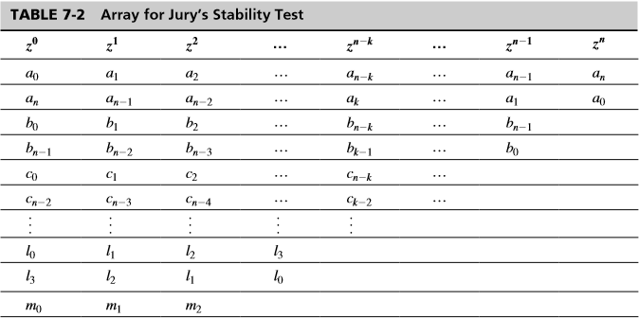

The jury’s tests:
